My network is **10.68.1.0/24**

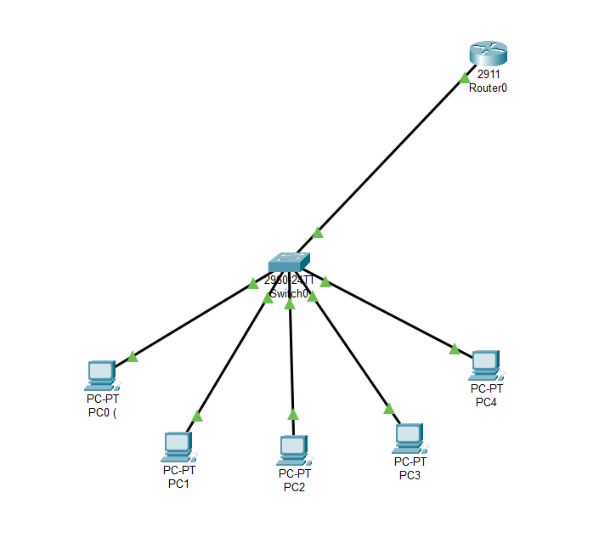

**ROUTER** CONFIGURATION:

enable

configure terminal

interface GigabitEthernet0/0

ip address 10.68.1.1 255.255.255.0

no shutdown

exit

**DHCP** ON THE ROUTER:

enable

configure terminal

ip dhcp excluded-address 10.68.1.1

ip dhcp pool MY_POOL

network 10.68.1.0 255.255.255.0

default-router 10.68.1.1

dns-server 8.8.8.8

exit

Then, PC’s CONFIGURATIONS look like in **DHCP** mode:

PC0 : 10.68.1.2 255.255.255.0 10.68.1.1

PC1 : 10.68.1.3 255.255.255.0 10.68.1.1

PC2 : 10.68.1.4 255.255.255.0 10.68.1.1

PC3 : 10.68.1.5 255.255.255.0 10.68.1.1

PC4 : 10.68.1.6 255.255.255.0 10.68.1.1

**STATIC** NAT ON ROUTER:

enable

configure terminal

interface GigabitEthernet0/0

ip nat outside

interface GigabitEthernet0/1

ip nat inside

exit

ip nat inside source static 10.68.1.2 203.0.113.1

ip nat inside source static 10.68.1.3 203.0.113.2

ip nat inside source static 10.68.1.4 203.0.113.3

ip nat inside source static 10.68.1.5 203.0.113.4

ip nat inside source static 10.68.1.6 203.0.113.5

**DYNAMIC** NAT ON ROUTER:

enable

configure terminal

ip nat pool MY_POOL 203.0.113.2 203.0.113.10 netmask 255.255.255.0

ip nat inside source list 1 pool MY_POOL overload

access-list 1 permit 10.68.1.0 0.0.0.255

interface GigabitEthernet0/0

ip nat outside

interface GigabitEthernet0/1

ip nat inside

exit

**—-------------------------------------------------END OF THE REPORT—--------------------------------------------------------**